Browsing Online Repositories

The vast amount of data stored in PRIDE can be accessed via the web interface or viewed in PRIDE Inspector1. Go on the PRIDE website (<http://www.ebi.ac.uk/pride>) and search PRIDE project number 1, and you will see the following:

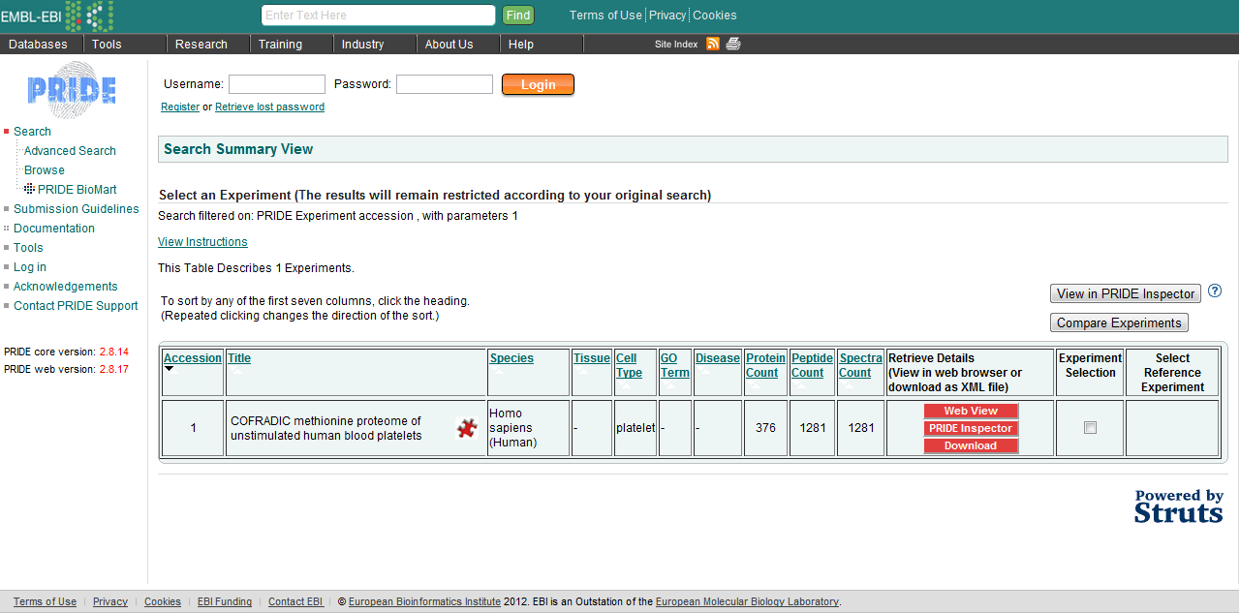

Click on ‘Web View’ to browse this project. *What information can you access regarding this experiment? What is your opinion about making all data available? [4.2a]*

It is possible to browse all online PRIDE datasets using PRIDE Inspector (<http://pride-toolsuite.googlecode.com>), available in the software folder. Starting PRIDE Inspector, you will see the following:

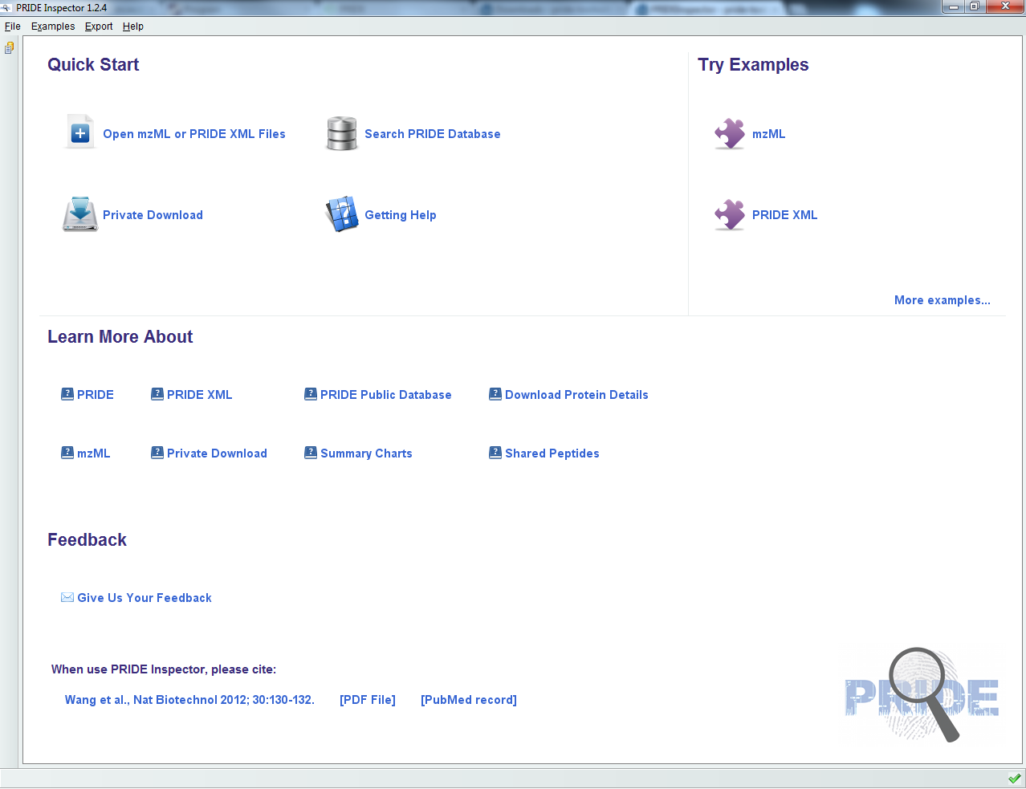

Select ‘Open mzML or PRIDE XML Files’ and open tutorial.xml located in the resources folder. You should see the following:

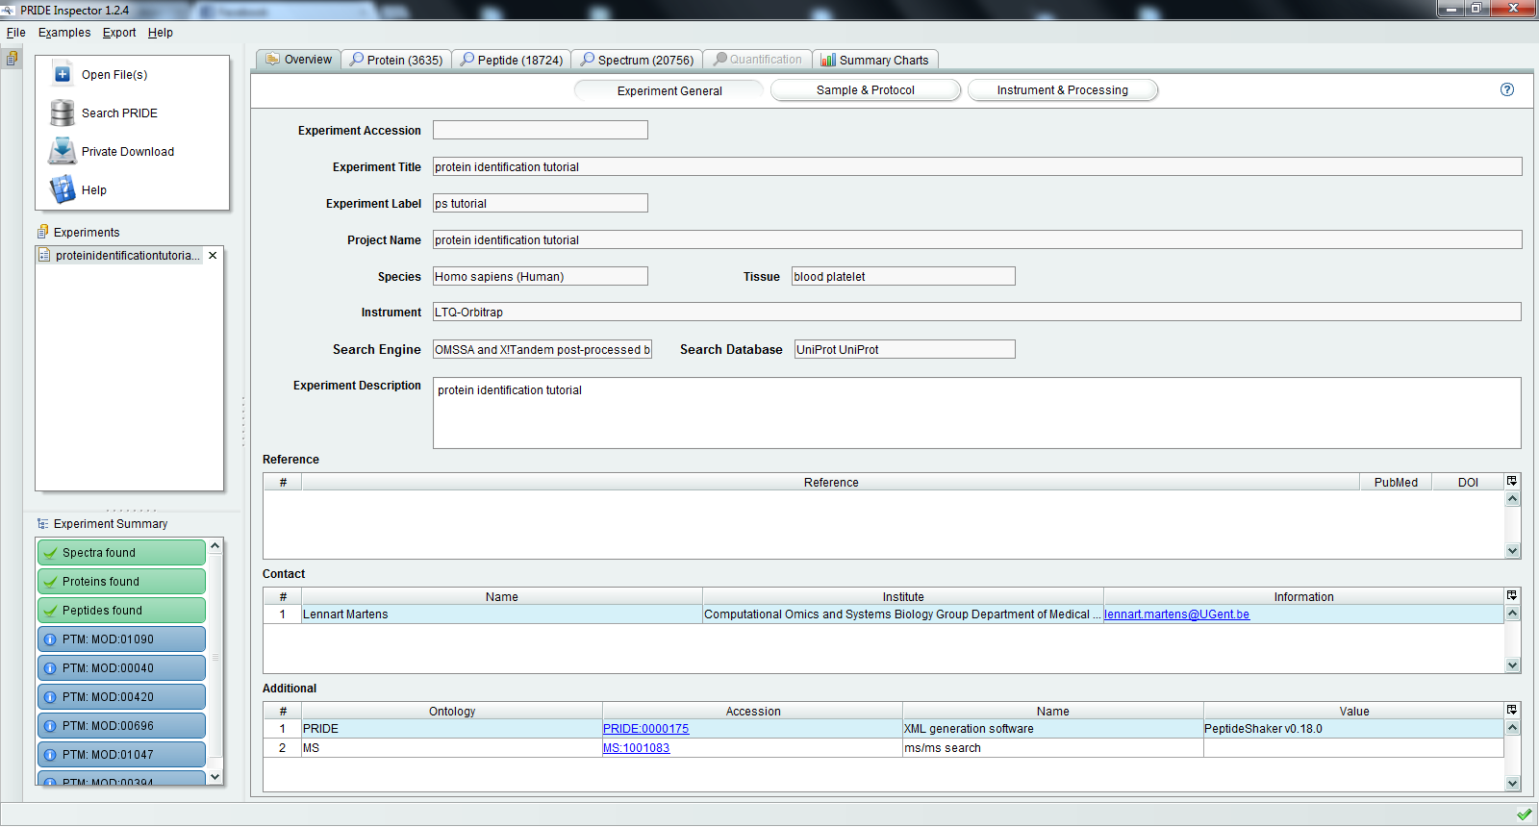

Note that all spectrum annotation (modifications, ions, etc.) have been passed by PeptideShaker to PRIDE Inspector as standardized terms and will thus be available for all other online resources. *What difference do you see compared to the PeptideShaker results? [4.2b]*

References

1. Wang, R. et al. PRIDE Inspector: a tool to visualize and validate MS proteomics data. *Nature biotechnology* **30**, 135-137 (2012).